
Oak Processionary Moth
Island wide
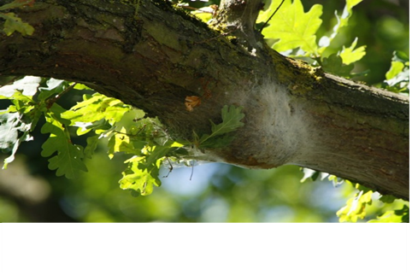
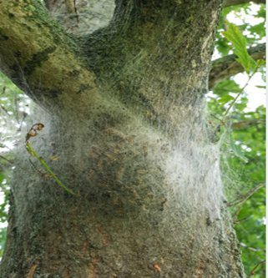
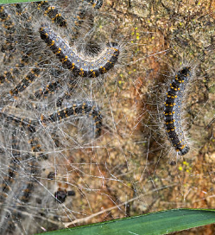

Caterpillars of oak processionary moth are found from May to August. They may also be identified by large white silken nests on the underside of branches, and on the trunk from which the caterpillars come out to feed on oak leaves. They are predominantly found on deciduous oak species.
How does it affect me?
Oak Processionary caterpillars have long hairs that can be shed. The hairs can cause severe rashes, respiratory problems if inhaled and may cause other severe allergic reactions. If seen, do not try to pick them up or touch them and keep your distance from trees where caterpillars may be present.
Please remain vigilant and report any sightings or possible sightings of oak processionary moth to Tom Dixon (Biosecurity Officer) at Natural Environment, Howard Davis Farm, Trinity. Tel: 441600 or email T.Dixon@gov.je.

<Add contact details if needed. Save as PDF or print.>

